**Making a Peanut Butter and Jelly Sandwich**

**Introduction:**

The peanut butter and jelly (or jam) sandwich is a quintessential American snack. It is quite popular in North America, especially among children[1]. It is a sandwich made my applying layers of peanut butter and jam/jelly over bread-loaves. The recipe was first published in a magazine called “Table Talk” in 18961 and today, many variations of this sandwich exist, and the ingredients can be substituted by other similarly textured ingredients.

**Ingredients**:

The information about the ingredients that go into making the peanut butter and jelly sandwich are as under:

1. Peanut Butter:

Peanut butter[2] is a type of paste/spread made by grinding dry roasted peanuts. It can contain added ingredients to enhance taste, such as sweeteners or salt. In the PB&J sandwich, peanut butter can be substituted by other spreads such as nut butters and chocolate spreads, for example: almond butter, cream cheese, Nutella etc. A 100gm serving of peanut butter contains 588 calories.

2. Jelly/Jam:

Jelly[3] is a type of spread made from the juice of fruits or vegetables. Jam, on the other hand, may be made from both the juice and the flesh of the fruits or vegetables. In a PB&J sandwich, one may choose to use jam or jelly. Other options may include honey, thin fruit slices etc. A typical serving of these fruit spreads can render 257 kCal of energy. There are a variety of fruit flavor options available: strawberries, mixed fruit, pineapples, raspberries, blueberries etc.

3. Bread:

The PB&J sandwich would typically need one or two slices of bread depending on the preference of the consumer. Both white or brown breads can be used in this recipe.

**An Overview of making the Peanut Butter and Jelly Sandwich:**

The main steps involved in making a peanut butter and jelly sandwich can be summarized as under:

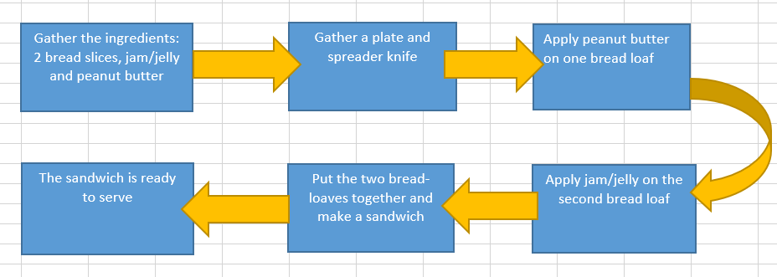

Figure 1: The above flowchart gives an overview of the steps involved in making a peanut butter and jelly sandwich

**Recipe for making the Peanut Butter and Jelly Sandwich:**

The below steps illustrate the recipe for making a peanut butter and jelly sandwich:

1. Make sure you are not allergic to any of the ingredients. In case of allergies, consider possible substitutions that are safe.
2. Get the ingredients from a local grocery store: Bread, peanut butter and jam/jelly (or substitutions as suitable). You would also need a plate and a spreading knife.
3. Lay two loaves of bread on a plate.
4. Using the spreader knife, apply enough peanut butter over one bread loaf to cover its surface area.
5. On the other bread loaf, apply jam/jelly using a spreader knife.

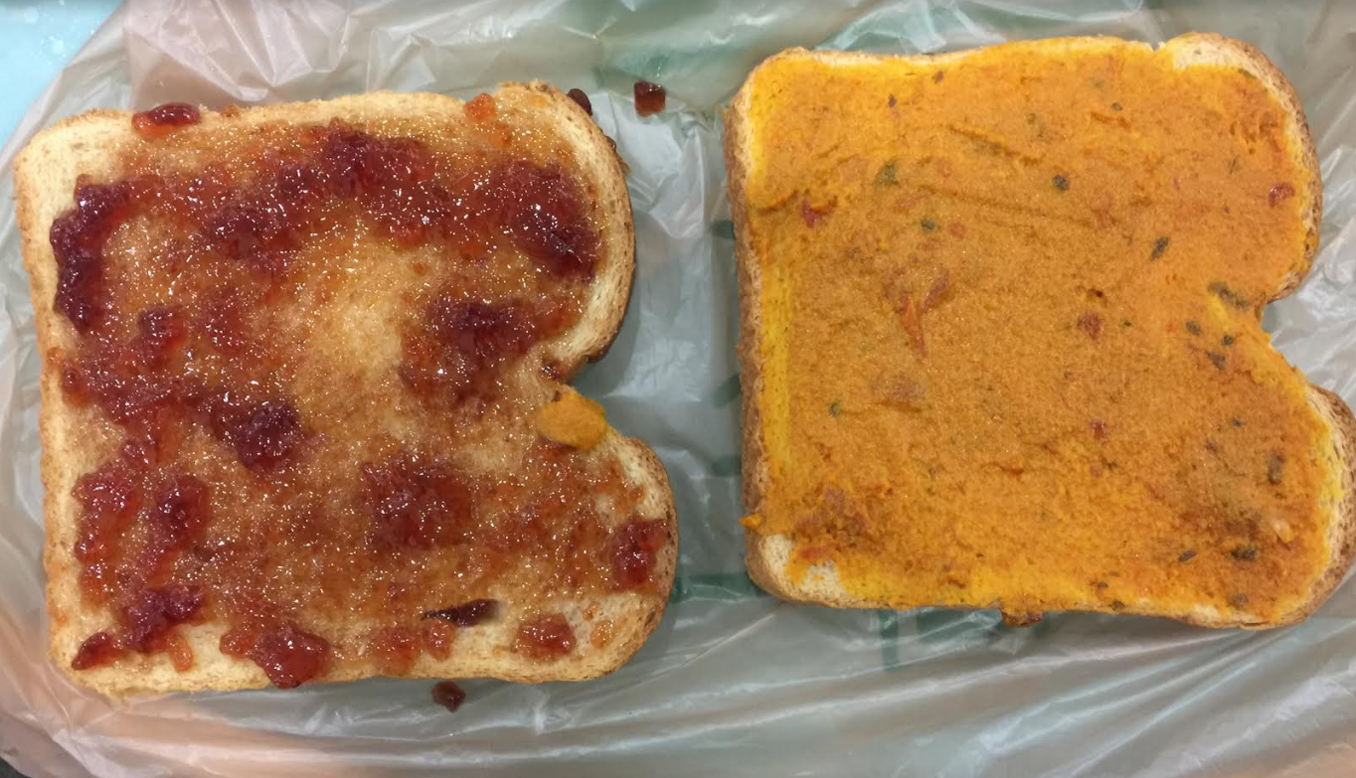

Figure 2: The above image demonstrates application of peanut butter and jam on the bread loaves.

1. Make sure you are applying equal amounts of peanut butter and jelly on the bread so that the taste of one ingredient does not overpower the other.
2. Put the two bread loaves together to make a sandwich with the sides with peanut butter and jam/jelly facing each other.

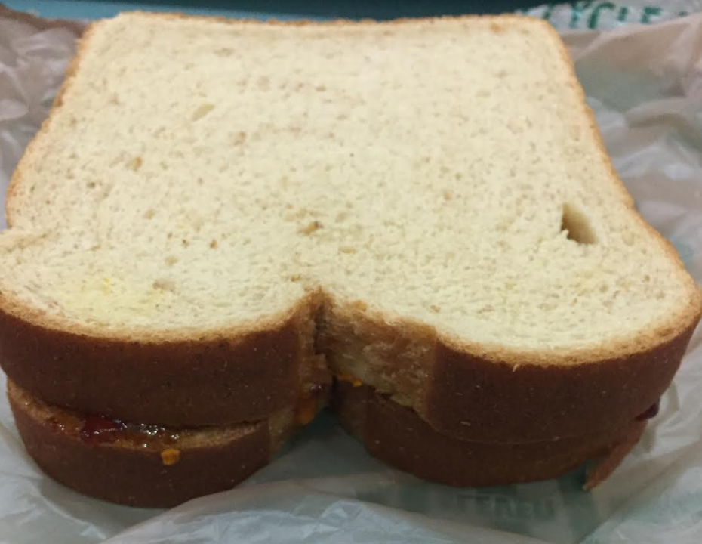

Figure 3: The above image demonstrates putting together the two bread loaves to make a sandwich

1. This sandwich can also be made open-faced using only one loaf of bread and spreading peanut butter and jam/jelly over it. Another option would be folding the single loaf instead of leaving it open-faced

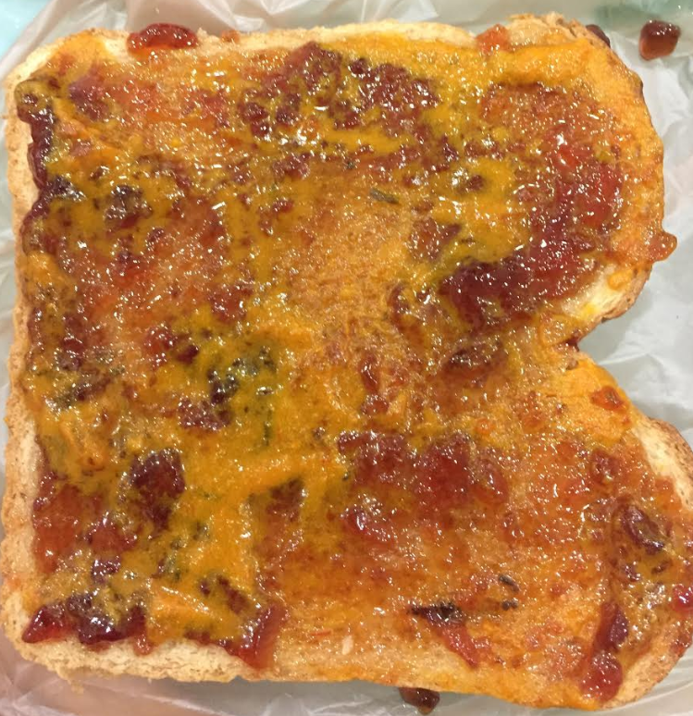

Figure 4: The above image shows an open-faced peanut butter and jelly sandwich

1. Optional: To make the sandwich visually more appealing, you may carve out interesting shapes on the bread slices using a knife or a molding device.

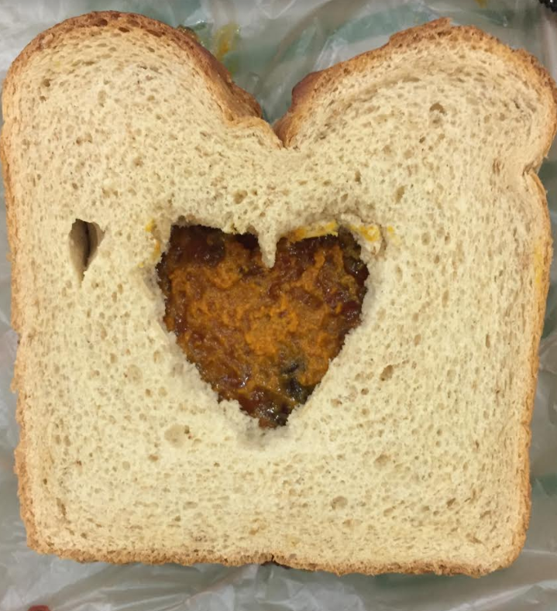

Figure 5: The above image shows a sandwich with a carving done using a knife

**Points to remember:**

1. Do not store the sandwich for longer hours as the peanut butter and jam/jelly spread can make the bread slices very soggy over time and damage the texture of bread.
2. It is important to do a prior check if the consumer is allergic to any of the ingredients such as sugar, peanuts, fruits, any flour used in the bread etc.
3. If you are nutrition-conscious, you may refer the below table for nutrition facts for one sandwich:

|  |  |
| --- | --- |
| **Component** | **Value[4]** |
| Energy | 403 kcal |
| Fat | 18 g |
| Carbohydrates | 58 g |
| Protein | 12 g |

Figure 6: The above table provides a summary of the nutritional information for a peanut butter and jelly sandwich

Word count: 763

1. Peanut butter and jelly sandwich (2018, October 2018). Retrieved from <https://en.wikipedia.org/wiki/Peanut_butter_and_jelly_sandwich>
2. Peanut butter (2018, September 16). Retrieved from <https://en.wikipedia.org/wiki/Peanut_butter>
3. Fruit preserves (2018, October 04).Retrieved from <https://en.wikipedia.org/wiki/Fruit_preserves#Jelly>
4. Peanut butter and jelly sandwich (2018, October 2018). Retrieved from <https://en.wikipedia.org/wiki/Peanut_butter_and_jelly_sandwich>